**Small Scale Collaborative Study for the Determination of Spirodiclofen Active in TC and SC by HPLC**



**Shandong Kangqiao Bio-Technology Co., Ltd.**

Mr Liu Ruibin, Ms Zhang Jianmei, Mr Sheng Guozhu

Lvyi Industrial Park, Boxing County, Shandong Province, China

May 2018

Content

1 Participants 3

2 Active Ingredient, General Information 3

3 Samples 4

4 Method 4

4.1 Outline of Method 4

4.2 Procedure for the collaborative trial 4

5 Remarks of the Participants 4

6 Evaluation and Discussion 4

7 Conclusions 5

8 Appendix: Tables and Figures for Spirodiclofen level 6

# Participants

|  |  |  |  |
| --- | --- | --- | --- |
| **Lab No.** | **Name of responsible person** | **Lab Name** | **City, Country** |
| 1 | Rose Feng | Analysis research development Dept of Jiangsu Rotam Chemistry Co., Ltd. | Jiangsu China |
| 2 | Yaffa Lu | GreenTech Laboratory Co., Ltd | ShangHai China |
| 3 | Chuanshan Yu | Beijing Mirrosyn Agro-chemical Testing Technology Co., Ltd. | Beijing. China |
| 4 | Shiling Wang | Shandong Kangqiao Biotechnology Co., Ltd Qingdao R &D center | Shandong China |

Laboratories were identified by a confidential number prior to the trial commencing

# Active Ingredient, General Information

|  |  |
| --- | --- |
| IUPAC name: | 3-(2,4-dichlorophenyl)-2-oxo-1-oxaspiro[4.5]dec-3-en-4-yl 2,2-dimethylbutyrate |
| ISO common name: | Spirodiclofen |
| CAS-No.: | 148477-71-8 |
| Structure: |  |
| Molecular mass: | 411.3 |
| Formula: | C21H24Cl2O4 |
| m.p. | 94.8°C |
| Solubility (g/L, 20℃) | In water 50 (pH 4), 190 (pH 7) (both in μg/l, 20 °C). In n-heptane 20, polyethylene glycol 24, n-octanol 44, isopropanol 47, DMSO 75, acetone, dichloromethane, ethyl acetate, acetonitrile and xylene >250 (all in g/l, 20 °C). |
| Stability | Decomposed under alkaline conditions |

# Samples

In April 2018 the following samples were sent to the participants:

1. 2018030610 Spirodiclofen Technical (TC-1)
2. 2018030713 Spirodiclofen Technical (TC-2)
3. 2018030603 Spirodiclofen Suspension Concentrate (SC-1)
4. 2018030602 Spirodiclofen Suspension Concentrate (SC-2)
5. 2018030601 Spirodiclofen Suspension Concentrate (SC-3)

Spirodiclofen, reference standard (purity 98.0%, w/w)

In May 2018 results were obtained.

# Method

## Outline of Method

Spirodiclofen is determined by reversed phase high performance liquid chromatography using UV detection at 260nm and external standardization.

## Procedure for the collaborative trial

The sample were analyzed on two different days with duplicate injections weighting per sample. Test and reference solutions were prepared fresh on each day. The sample content was calculated using the mean value of the duplicate injections.

# Remarks of the Participants

|  |  |  |  |  |  |
| --- | --- | --- | --- | --- | --- |
| Lab | Liquid Chromatograph Integrator | Column | Mobile Phase | Flow rate  ml/min | Column temp（℃） |
| 1 | Shimadzu 20A with PDA detector | Waters XBridge C18, 4.6×250mm 5 μm | Methanol +Water =90+10(v/v) | 1.0 | 25 |
| 2 | Shimadzu, LC-20AT with SPD-M20A detector | Agilent Extend C18, 250mm×4.6mm, 5μm, SN | Methanol +Water =90+10(v/v) | 1.0 | 25 |
| 3 | Thermo (Dionex) Ultimate 3000 HPLC with DAD detector | Agela; Innoval ODS-2 250cm×4.6mm, 5μm; | Methanol +Water =90+10(v/v) | 1.0 | 25 |
| 4 | Agilent 1260 series HPLC with DAD detector | ODS column 4.6 I.D.× 250 mm | Methanol +Water =90+10(v/v) | 1.0 | 25 |

# Evaluation and Discussion

The full results of four labs were included within the statistical assessment. The statistical evaluation of the data was accomplished following the “Guidelines for CIPAC Collaborative Study Procedures for Assessment of Performance of Analytical Methods”, according to DIN ISO 5725.

The assay results obtained by the collaborators and the statistical evaluation are reported in Table 1, Table 2 and Tables 3-1 to 3-5. The discussion on stragglers and outliers is as follows:

**SC-1**

The statistical analysis shows that the data in lab 3 is an outlier on Cochran’s test and a straggler on Grubbs’s test.

# Conclusions

For all samples, the values of RSDR (reproducibility relative standard deviation) were less than Horwitz’s value even if outliers on Cochran’s test were included. As a reference, all HorRat values were not greater than 1.0. The proposed method is considered to be appropriate for the determination of spirodiclofen in technical material and suspension concentrate.

CHIPAC proposes to proceed with a large scale collaborative study.

# Appendix: Tables and Figures for Spirodiclofen level

Table 1: Summary of the statistical evaluation no elimination of any outliers

|  |  |  |  |  |  |
| --- | --- | --- | --- | --- | --- |
|  | **TC-1** | **TC-2** | **SC-1** | **SC-2** | **SC-3** |
| **Xm** | 981.5 | 981.6 | 218.5 | 217.7 | 221.6 |
| **L** | 4 | 4 | 4 | 4 | 4 |
| **Sr** | 1.6 | 1.7 | 1.2 | 0.8 | 0.6 |
| **SL** | 1.2 | 2.1 | 1.5 | 2.5 | 4.9 |
| **SR** | 2.0 | 2.7 | 1.9 | 2.7 | 4.9 |
| **r** | 4.5 | 4.7 | 3.4 | 2.3 | 1.7 |
| **R** | 5.7 | 7.6 | 5.4 | 7.5 | 13.7 |
| **RSDr** | 0.17 | 0.17 | 0.55 | 0.38 | 0.27 |
| **RSDR** | 0.21 | 0.28 | 0.89 | 1.23 | 2.21 |
| **RSDR (Hor)** | 2.0 | 2.0 | 2.5 | 2.5 | 2.5 |

**Table 2: Summary of the statistical evaluation with elimination of outliers**

|  |  |  |  |  |  |
| --- | --- | --- | --- | --- | --- |
|  | **TC-1** | **TC-2** | **SC-1** | **SC-2** | **SC-3** |
| **Xm** | 981.5 | 981.6 | 219.4 | 217.7 | 221.6 |
| **L** | 4 | 4 | 4 | 4 | 4 |
| **Sr** | 1.6 | 1.7 | 0.6 | 0.8 | 0.6 |
| **SL** | 1.2 | 2.1 | 0.0 | 2.5 | 4.9 |
| **SR** | 2.0 | 2.7 | 0.6 | 2.7 | 4.9 |
| **r** | 4.5 | 4.7 | 1.8 | 2.3 | 1.7 |
| **R** | 5.7 | 7.6 | 1.8 | 7.5 | 13.7 |
| **RSDr** | 0.17 | 0.17 | 0.29 | 0.38 | 0.27 |
| **RSDR** | 0.21 | 0.28 | 0.29 | 1.23 | 2.21 |
| **RSDR (Hor)** | 2.0 | 2.0 | 2.5 | 2.5 | 2.5 |

Xm = average

L = number of laboratories

Sr  = repeatability standard deviation

SL = "pure" between laboratory standard variation

SR = reproducibility standard deviation

RSDr  = repeatability relative standard deviation

RSDR  = reproducibility relative standard deviation

r = repeatability

R = reproducibility

RSDR (Hor) = Horwitz value calculated from: 2^(1 - 0.5log c) where c = the concentration of the analyte as a decimal fraction

**Table 3-1 Spirodiclofen Technical-1 (2018030610)**

|  |  |  |  |  |  |  |  |  |  |
| --- | --- | --- | --- | --- | --- | --- | --- | --- | --- |
| **Lab** | **Analytical data (n=4)** | | | | | **Yi** | **Yi2** | **Si** | **Si2** |
| 1 | Day1 | | 983.2 | 982.8 | | 983.7 | 967567.32 | 0.873 | 0.762 |
| Day2 | | 984.8 | 983.9 | |
| 2 | Day1 | | 978.6 | 980.9 | | 980.3 | 961082.75 | 1.233 | 1.521 |
| Day2 | | 980.5 | 981.4 | |
| 3 | Day1 | | 980.4 | 983.5 | | 981.0 | 962434.51 | 1.696 | 2.878 |
| Day2 | | 979.7 | 980.6 | |
| 4 | Day1 | | 978.8 | 983.6 | | 980.9 | 962115.77 | 2.320 | 5.383 |
| Day2 | | 979.1 | 982.0 | |
| S1 | sum Yi | |  |  | | 3925.9 |  |  |  |
| S2 | sum Yi2 | |  |  | |  | 3853200.35 |  |  |
| S3 | sum Si2 | |  |  | |  |  |  | 10.543 |
|  |  | |  |  | |  |  |  |  |
| p=4 | n=4 | | ** Regarded as a statistical outlier | | | |  |  |  |
| **1) Cochran's test (p=4, n=4)** | | | |  | |  |  |  |  |
| C=Si2max/S3=0.510519＜0.684 （p=4, n=4, 5%) | | | | | | |  |  |  |
|  |  | |  |  | |  |  |  |  |
| **2) Grubbs's test (p=4, n=4)** | | | |  | |  |  |  |  |
| Yi min= | | 980.35 | Yi max= | 983.65 | | Y= | 981.48 |  |  |
| Y-Yi min= | | 1.13 | Yi max-Y= | 2.17 | | S= | 1.478 |  |  |
| lower= | | 0.764 | ＜1.481 (p=4, 5%) | | |  |  |  |  |
| upper= | | 1.470 | ＜1.481 (p=4, 5%) | | |  |  |  |  |
|  | |  |  |  | |  |  |  |  |
| **3) Calculation of r and R** | | | |  | |  |  |  |  |
| Mean: Y=S1/p= | | |  |  | | 981.48 |  |  |  |
| Sr2= | S3/p= | |  |  | | 2.636 | Sr= | 1.624 |  |
| SL2= | [(pS2-S12)/p(p-1)]- Sr2/n= | | | | | 1.525 | SL= | 1.235 |  |
| SR2= | Sr2+SL2= | |  |  | | 4.161 | SR= | 2.040 |  |
|  |  | |  |  | |  |  |  |  |
| r= | 2.8*Sr= | |  | 4.546 | |  |  |  |  |
| R= | 2.8*SR= | |  | 5.711 | |  |  |  |  |
| RSDr= | (Sr/mean)*100= | | | 0.165 | |  |  |  |  |
| RSDR= | (SR/mean)*100= | | | 0.208 | |  |  |  |  |
|  |  | |  |  | |  |  |  |  |
| Horwitz's value= | | | 2^[1-0.5*log(Y/1000)]= |  | | 2.005 |  |  |  |
| RSDr and RSDR＜2.005（Horwitz's value) | | | | | |  |  |  |  |
| HorRat value= | | | RSDR/Horwitz's value= | |  | 0.104 |  |  |  |

**Table 3-2 Spirodiclofen Technical-2 (2018030713)**

|  |  |  |  |  |  |  |  |  |
| --- | --- | --- | --- | --- | --- | --- | --- | --- |
| **Lab** | **Analytical data (n=4)** | | | | **Yi** | **Yi2** | **Si** | **Si2** |
| 1 | Day1 | | 982.3 | 984.3 | 982.7 | 965674.72 | 1.213 | 1.471 |
| Day2 | | 981.4 | 982.8 |
| 2 | Day1 | | 976.9 | 980.1 | 978.8 | 958019.63 | 2.048 | 4.195 |
| Day2 | | 977.2 | 981.0 |
| 3 | Day1 | | 984.1 | 985.8 | 984.0 | 968350.66 | 2.242 | 5.028 |
| Day2 | | 985.5 | 980.9 |
| 4 | Day1 | | 980.8 | 982.0 | 980.8 | 961919.60 | 0.881 | 0.776 |
| Day2 | | 980.0 | 980.3 |
| S1 | sum Yi | |  |  | 3926.3 |  |  |  |
| S2 | sum Yi2 | |  |  |  | 3853964.61 |  |  |
| S3 | sum Si2 | |  |  |  |  |  | 11.469 |
|  |  | |  |  |  |  |  |  |
| p=4 | n=4 | |  |  |  |  |  |  |
| **1) Cochran's test (p=4, n=4)** | | | |  |  |  |  |  |
| C=Si2max/S3=0.438306＜0.684 （p=4, n=4, 5%) | | | | | |  |  |  |
|  |  | |  |  |  |  |  |  |
| **2) Grubbs's test (p=4, n=4)** | | | |  |  |  |  |  |
| Yi min= | 978.78 | | Yi max= | 984.05 | Y= | 981.57 |  |  |
| Y-Yi min= | 2.79 | | Yi max-Y= | 2.47 | S= | 2.293 |  |  |
| lower= | 1.216 | | ＜1.481 (p=4, 5%) | |  |  |  |  |
| upper= | 1.079 | | ＜1.481 (p=4, 5%) | |  |  |  |  |
|  |  | |  |  |  |  |  |  |
| **3) Calculation of r and R** | | | |  |  |  |  |  |
| Mean: Y=S1/p= | | |  |  | 981.6 |  |  |  |
| Sr2= | S3/p= | |  |  | 2.867 | Sr= | 1.693 |  |
| SL2= | [(pS2-S12)/p(p-1)]-Sr2/n= | | | | 4.543 | SL= | 2.131 |  |
| SR2= | Sr2+SL2= | |  |  | 7.410 | SR= | 2.722 |  |
|  |  | |  |  |  |  |  |  |
| r= | 2.8*Sr= | |  | 4.741 |  |  |  |  |
| R= | 2.8*SR= | |  | 7.622 |  |  |  |  |
| RSDr= | (Sr/mean)*100= | | | 0.173 |  |  |  |  |
| RSDR= | (SR/mean)*100= | | | 0.277 |  |  |  |  |
|  |  | |  |  |  |  |  |  |
| Horwitz's value= | | | 2^[1-0.5*log(Y/1000)]= |  | 2.006 |  |  |  |
| RSDr and RSDR＜2.006（Horwitz's value) | | | | |  |  |  |  |
| HorRat value= | | RSDR/Horwitz's value= | |  | 0.138 |  |  |  |

**Table 3-3 Spirodiclofen Suspension Concentrate-1 (2018030601)**

|  |  |  |  |  |  |  |  |  |
| --- | --- | --- | --- | --- | --- | --- | --- | --- |
| **Lab** | **Analytical data (n=4)** | | | **Yi** | | **Yi2** | **Si** | **Si2** |
| 1 | Day1 | 219.0 | 218.9 | 219.2 | | 48065.08 | 0.437 | 0.191 |
| Day2 | 219.9 | 219.3 |
| 2 | Day1 | 218.3 | 218.9 | 219.1 | | 48025.96 | 0.674 | 0.454 |
| Day2 | 219.5 | 219.9 |
| 3 | Day1 | 216.6 | 218.9 | 216.1** | | 46703.12 | 2.126 | 4.518 |
| Day2 | 214.2 | 214.7 |
| 4 | Day1 | 219.8 | 219.4 | 219.7 | | 48268.09 | 0.762 | 0.580 |
| Day2 | 218.9 | 220.7 |
| S1 | sum Yi |  |  | 874.2 | |  |  |  |
| S2 | sum Yi2 |  |  |  | | 191062.25 |  |  |
| S3 | sum Si2 |  |  |  | |  |  | 5.743 |
|  |  |  |  |  | |  |  |  |
| p=4 | n=4 |  | ** Regarded as a statistical outlier | | | | |  |
| **1) Cochran's test (p=4, n=4)** | | |  |  | |  |  |  |
| C=Si2max/S3=0.786766 | | | ＞0.684 (p=4, n=4, 5%) | | | |  |  |
|  |  |  | ＞0.781 (p=4, n=4, 1%) | | | |  |  |
| **2) Grubbs's test (p=4, n=4)** | | |  | |  |  |  |  |
| Yi min= | 216.11 | Yi max= | 219.70 | | Y= | 218.5 |  |  |
| Y-Yi min= | 2.44 | Yi max-Y= | 1.15 | | S= | 1.644 |  |  |
| lower= | 1.484 | ＞1.481 (p=4, 5%) | | |  |  |  |  |
|  |  | ＜1.496 (p=4, 1% |  | |  |  |  |  |
| upper= | 0.700 | ＜1.481 (p=4, 5%) | | |  |  |  |  |
|  |  |  |  | |  |  |  |  |
| **3) Calculation of r and R** | | |  | |  |  |  |  |
| Mean: Y=S1/p= | |  |  | | 218.5 |  |  |  |
| Sr2= | S3/p= |  |  | | 1.436 | Sr= | 1.198 |  |
| SL2= | [(pS2-S12)/p(p-1)]- Sr2= | | | | 2.345 | SL= | 1.531 |  |
| SR2= | Sr2+SL2= |  |  | | 3.781 | SR= | 1.944 |  |
|  |  |  |  | |  |  |  |  |
| r= | 2.8*Sr= |  | 3.355 | |  |  |  |  |
| R= | 2.8*SR= |  | 5.444 | |  |  |  |  |
| RSDr= | (Sr/mean)*100= | | 0.548 | |  |  |  |  |
| RSDR= | (SR/mean)*100= | | 0.890 | |  |  |  |  |
|  |  |  |  | |  |  |  |  |
| Horwitz's value= | | 2^[1-0.5*log(Y/1000)]= |  | | 2.514 |  |  |  |
| RSDr and RSDR＜2.514（Horwitz's value) | | | | |  |  |  |  |
| HorRat value= | | RSDR/Horwitz's value= | |  | 0.354 |  |  |  |

**Table 3-4 Spirodiclofen Suspension Concentrate-2 (2018030602)**

|  |  |  |  |  |  |  |  |  |  |
| --- | --- | --- | --- | --- | --- | --- | --- | --- | --- |
| **Lab** | **Analytical data (n=4)** | | | | | **Yi** | **Yi2** | **Si** | **Si2** |
| 1 | Day1 | 219.0 | | 219.4 | | 219.1 | 47982.90 | 0.342 | 0.117 |
| Day2 | 218.6 | | 219.2 | |
| 2 | Day1 | 217.1 | | 217.0 | | 217.7 | 47404.55 | 0.780 | 0.608 |
| Day2 | 218.5 | | 218.3 | |
| 3 | Day1 | 215.4 | | 212.6 | | 214.1 | 45842.87 | 1.310 | 1.716 |
| Day2 | 215.0 | | 213.5 | |
| 4 | Day1 | 220.7 | | 219.7 | | 220.0 | 48389.00 | 0.562 | 0.316 |
| Day2 | 219.4 | | 220.1 | |
| S1 | sum Yi |  | |  | | 870.9 |  |  |  |
| S2 | sum Yi2 |  | |  | |  | 189619.32 |  |  |
| S3 | sum Si2 |  | |  | |  |  |  | 2.756 |
|  |  |  | |  | |  |  |  |  |
| p=4 | n=4 |  | |  | |  |  |  |  |
| **1) Cochran's test (p=4, n=4)** | | | |  | |  |  |  |  |
| C=Si2max/S3=0.622447 | | | | ＜0.684 （p=4, n=4, 5%) | | | |  |  |
|  |  |  | |  | |  |  |  |  |
| **2) Grubbs's test (p=4, n=4)** | | | |  | |  |  |  |  |
| Yi min= | 214.11 | | Yi max= | 219.98 | | Y= | 217.72 |  |  |
| Y-Yi min= | 3.61 | | Yi max-Y= | 2.26 | | S= | 2.575 |  |  |
| lower= | 1.400 | | ＜1.481 (p=4, 5%) | | |  |  |  |  |
| upper= | 0.878 | | ＜1.481 (p=3, 5%) | | |  |  |  |  |
|  |  | |  |  | |  |  |  |  |
| **3) Calculation of rand R** | | |  |  | |  |  |  |  |
|  |  | |  |  | |  |  |  |  |
| Mean: Y=S1/p= | | |  |  | | 217.7 |  |  |  |
| Sr2= | S3/p= | |  |  | | 0.689 | Sr= | 0.830 |  |
| SL2= | [(pS2-S12)/p(p-1)]-Sr2/n= | | | | | 6.458 | SL= | 2.541 |  |
| SR2= | Sr2+SL2= |  | |  | | 7.147 | SR= | 2.673 |  |
|  |  |  | |  | |  |  |  |  |
| r= | 2.8*Sr= |  | | 2.324 | |  |  |  |  |
| R= | 2.8*SR= |  | | 7.486 | |  |  |  |  |
| RSDr= | (Sr/mean)*100= | | | 0.381 | |  |  |  |  |
| RSDR= | (SR/mean)*100= | | | 1.228 | |  |  |  |  |
|  |  |  | |  | |  |  |  |  |
| Horwitz's value= | | 2^[1-0.5*log(Y/1000)]= | |  | | 2.516 |  |  |  |
| RSDr and RSDR＜2.516（Horwitz's value) | | | | | |  |  |  |  |
| HorRat value= | | RSDR/Horwitz's value= | | |  | 0.488 |  |  |  |

**Table 3-5 Spirodiclofen Suspension Concentrate-2 (2018030603)**

|  |  |  |  |  |  |  |  |  |  |  |
| --- | --- | --- | --- | --- | --- | --- | --- | --- | --- | --- |
| **Lab** | **Analytical data (n=4)** | | | | | | **Yi** | **Yi2** | **Si** | **Si2** |
| 1 | Day1 | | 222.6 | | 223.1 | | 222.8 | 49650.98 | 0.882 | 0.777 |
| Day2 | | 221.8 | | 223.9 | |
| 2 | Day1 | | 224.6 | | 224.1 | | 224.8 | 50554.34 | 0.614 | 0.377 |
| Day2 | | 225.6 | | 225.1 | |
| 3 | Day1 | | 214.3 | | 213.9 | | 214.4 | 45949.62 | 0.366 | 0.134 |
| Day2 | | 214.8 | | 214.4 | |
| 4 | Day1 | | 224.6 | | 223.6 | | 224.2 | 50254.43 | 0.419 | 0.176 |
| Day2 | | 224.3 | | 224.2 | |
| S1 | sum Yi | |  | |  | | 886.2 |  |  |  |
| S2 | sum Yi2 | |  | |  | |  | 196409.38 |  |  |
| S3 | sum Si2 | |  | |  | |  |  |  | 1.464 |
|  |  | |  | |  | |  |  |  |  |
| p=4 | n=4 | |  | |  | |  |  |  |  |
| **1) Cochran's test (p=4, n=4)** | | | | |  | |  |  |  |  |
| C=Si2max/S3=0.531012 | | | | | ＜0.684 （p=4, n=4, 5%) | | | |  |  |
|  |  | |  | |  | |  |  |  |  |
| **2) Grubbs's test (p=4, n=4)** | | | | |  | |  |  |  |  |
| Yi min= | | 214.36 | | Yi max= | 224.84 | | Y= | 221.55 |  |  |
| Y-Yi min= | | 7.19 | | Yi max-Y= | 3.29 | | S= | 4.867 |  |  |
| lower= | | 1.478 | | ＜1.481 (p=4, 5%) | | |  |  |  |  |
| upper= | | 0.676 | | ＜1.481 (p=4, 5%) | | |  |  |  |  |
|  | |  | |  |  | |  |  |  |  |
| **3)Calculation of rand R** | | | |  |  | |  |  |  |  |
|  |  | | |  |  | |  |  |  |  |
| Mean: Y=S1/p= | | | |  |  | | 221.6 |  |  |  |
| Sr2= | S3/p= | | |  |  | | 0.366 | Sr= | 0.605 |  |
| SL2= | [(pS2-S12)/p(p-1)]-Sr2/n= | | | | | | 23.600 | SL= | 4.858 |  |
| SR2= | Sr2+SL2= | |  | |  | | 23.966 | SR= | 4.896 |  |
|  |  | |  | |  | |  |  |  |  |
| r= | 2.8*Sr= | |  | | 1.694 | |  |  |  |  |
| R= | 2.8*SR= | |  | | 13.707 | |  |  |  |  |
| RSDr= | (Sr/mean)*100= | | | | 0.273 | |  |  |  |  |
| RSDR= | (SR/mean)*100= | | | | 2.210 | |  |  |  |  |
|  |  | |  | |  | |  |  |  |  |
| Horwitz's value= | | | 2^[1-0.5*log(Y/1000)]= | |  | | 2.509 |  |  |  |
| RSDr and RSDR＜2.509（Horwitz's value) | | | | | | |  |  |  |  |
| HorRat value= | | | RSDR/Horwitz's value= | | |  | 0.881 |  |  |  |

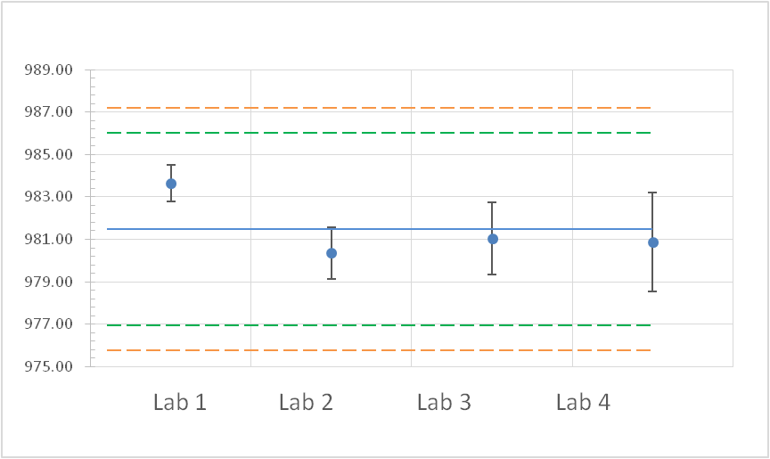

Figure 1 Spirodiclofen Technical-1

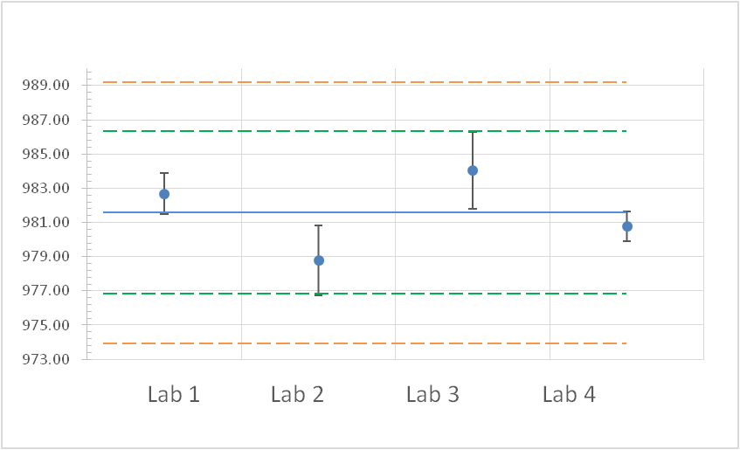

Figure 2 Spirodiclofen Technical-2

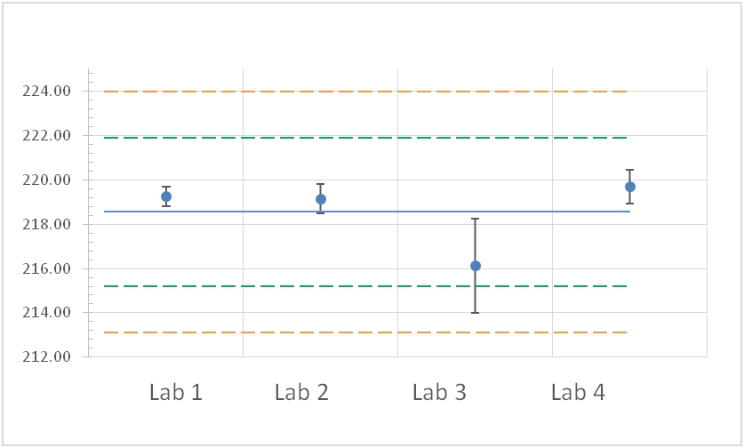

Figure 3 Spirodiclofen Suspension Concentrate-1

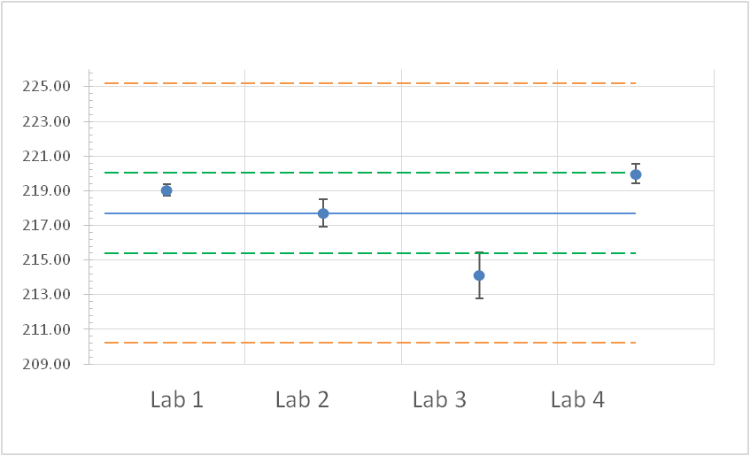

Figure 4 Spirodiclofen Suspension Concentrate-2

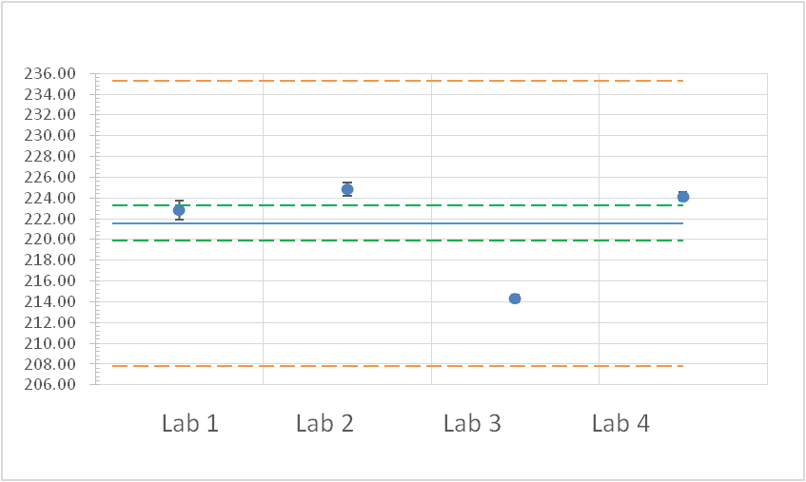

Figure 5 Spirodiclofen Suspension Concentrate-3